AIPP LAB 14
Name: CH HARSHITHA
Hall Ticket No.: 2503B05135
Date: 25/11/2025 (Week 5)
___________________________________________________
Completed this Assignment using VS CODE Al Integration.
Task 1:
Ask AI to generate a simple HTML homepage for a "Student Info Portal" with a header, navigation menu, and footer.
CODE:
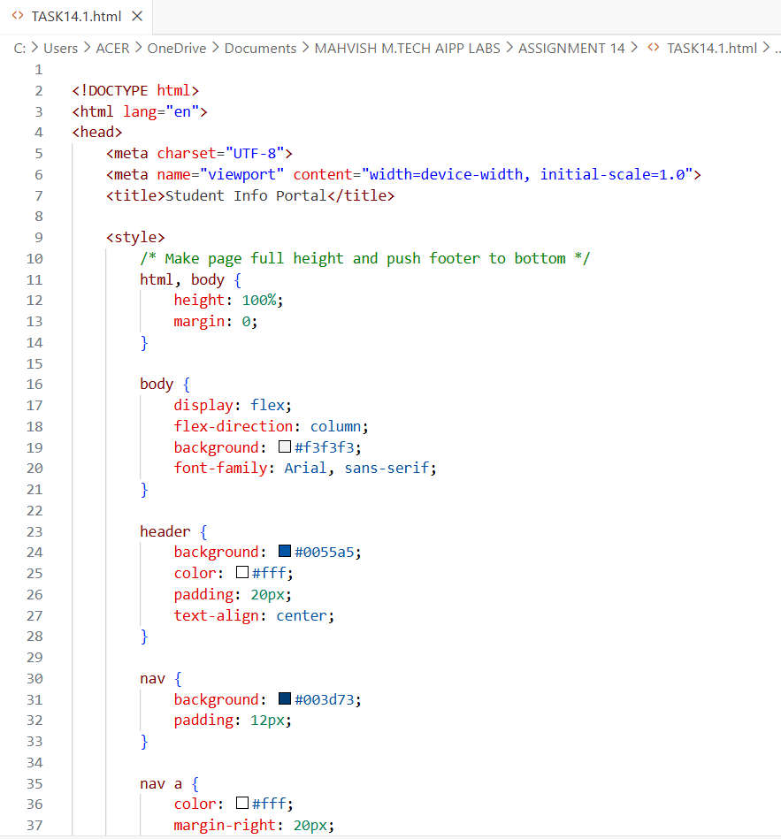
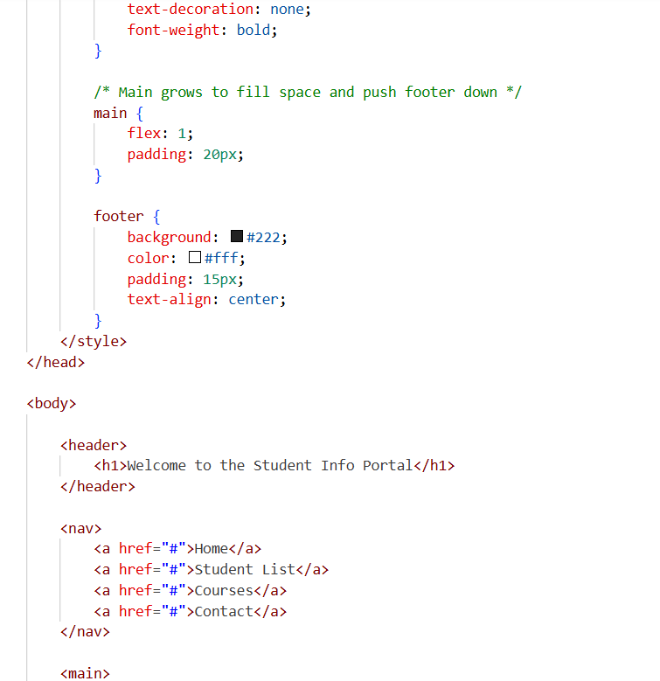
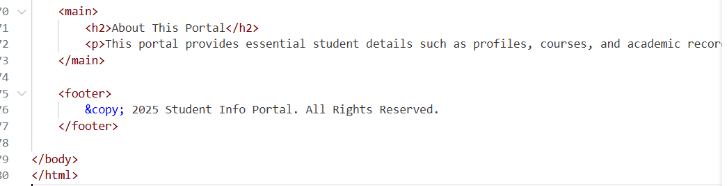OUTPUT:
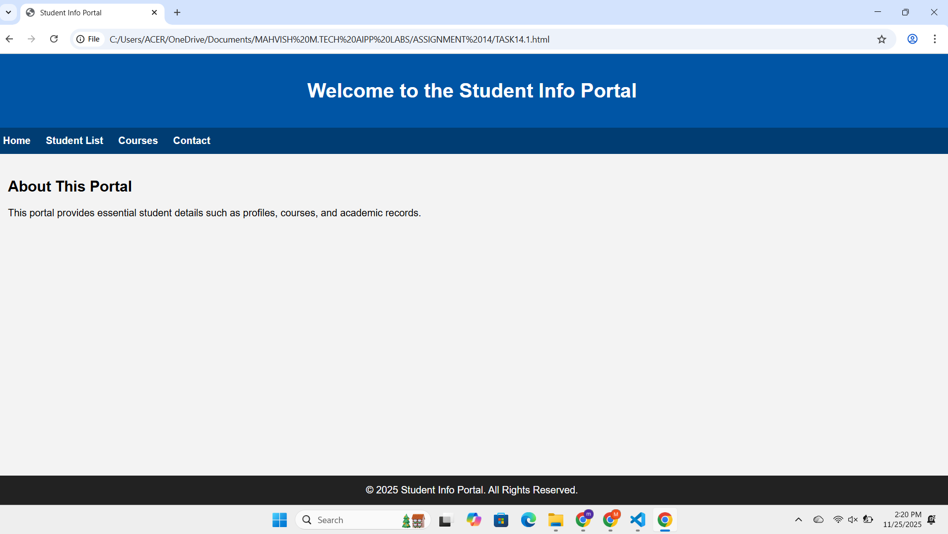
Task 2:
Use AI to add CSS styling to Task #1 homepage for:
● Responsive navigation bar.
● Centered content section.
● Footer with light gray background.
CODE:
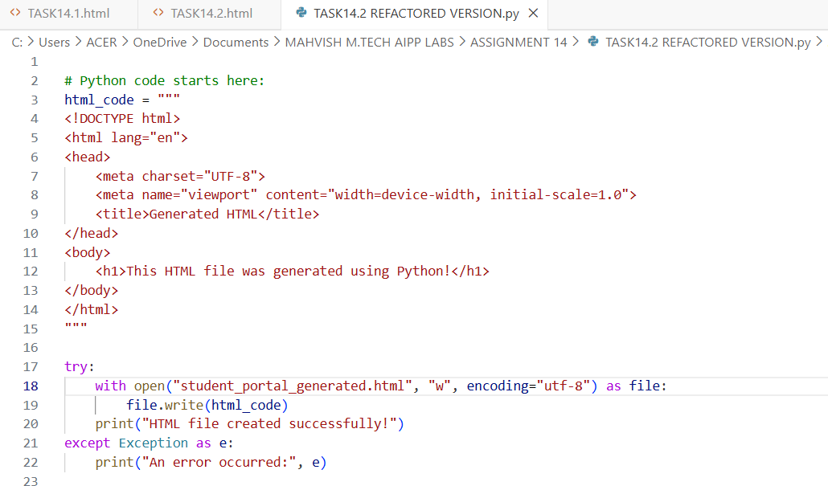
OUTPUT:

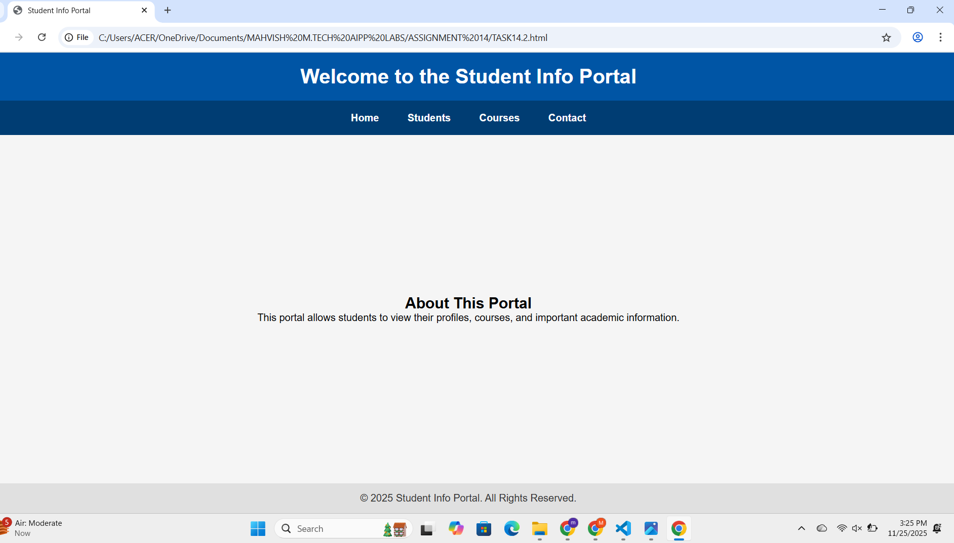
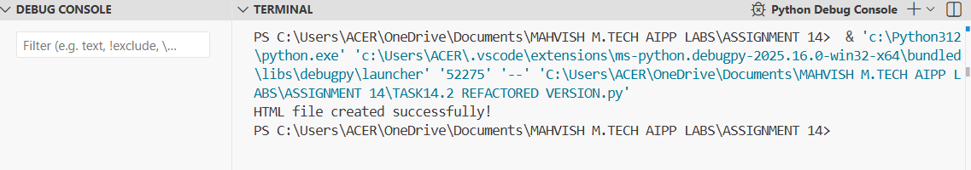Task 3:
Prompt AI to generate a JS script that validates a simple login
form (non-empty username/password).
CODE:
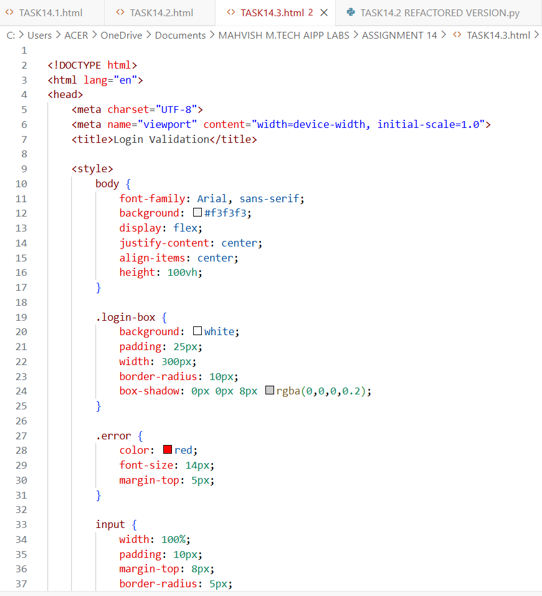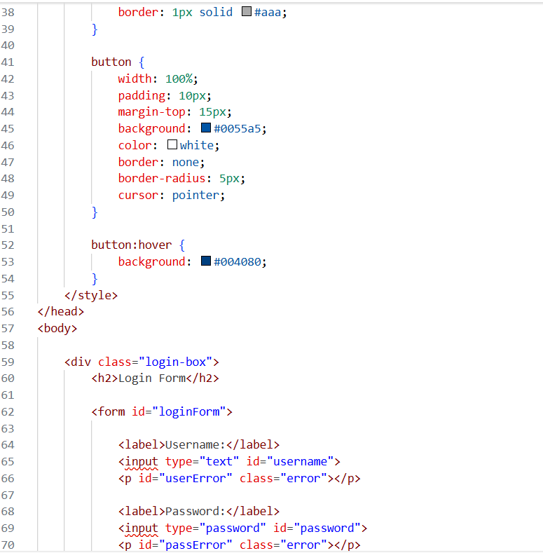
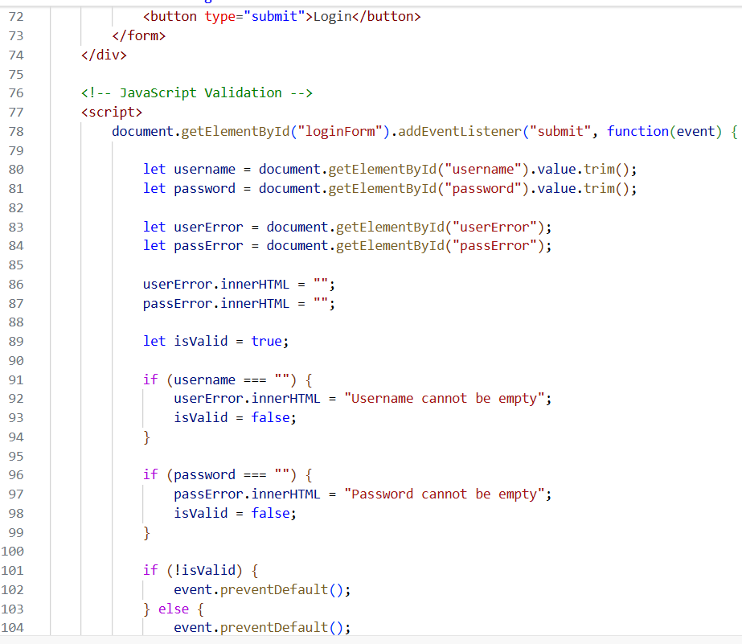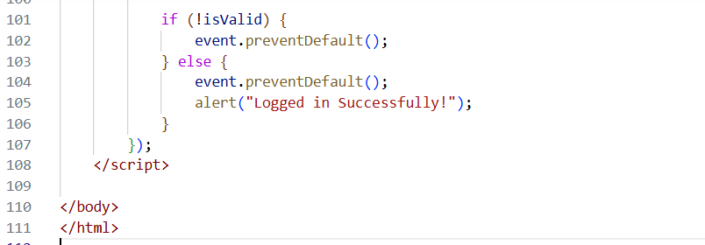
OUTPUT:
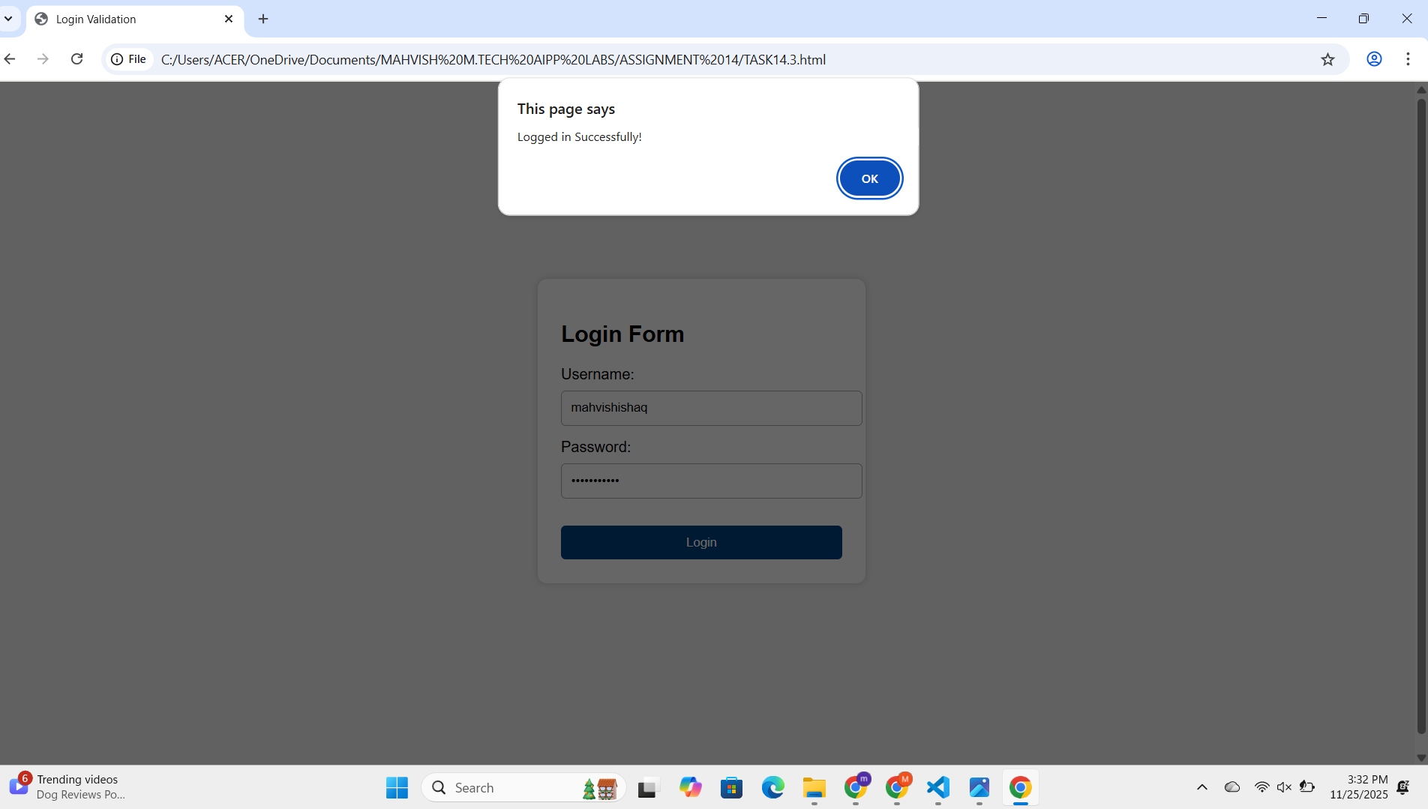
Task 4:
Ask AI to generate a Flask app that serves the HTML form (Task
#3) and prints the username on successful login.
CODE:
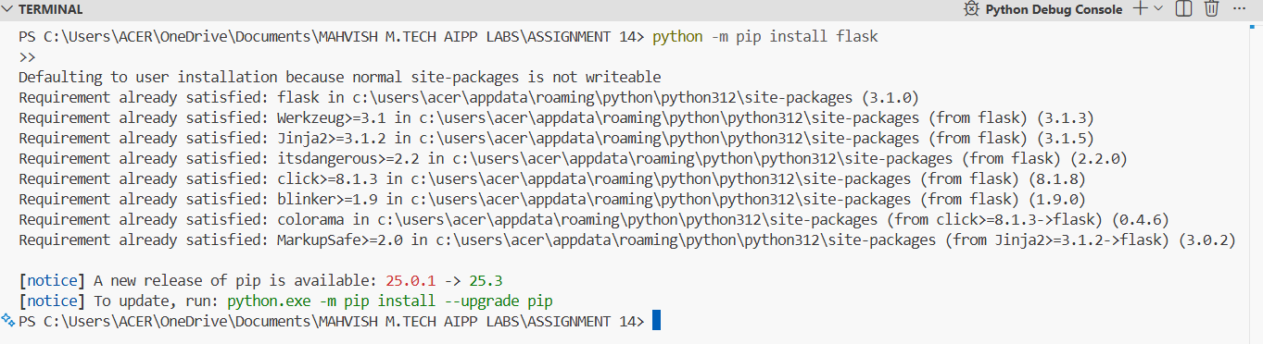
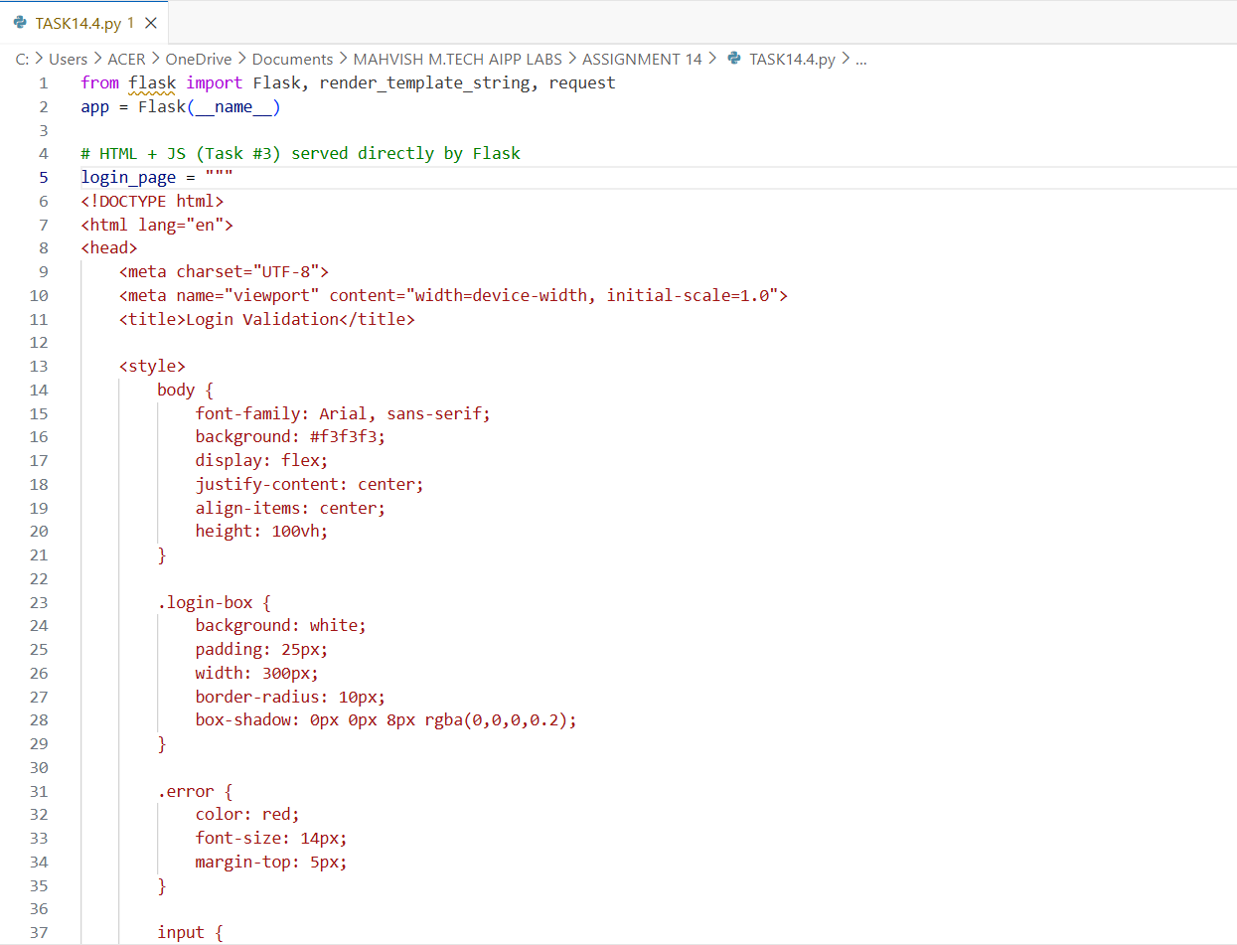

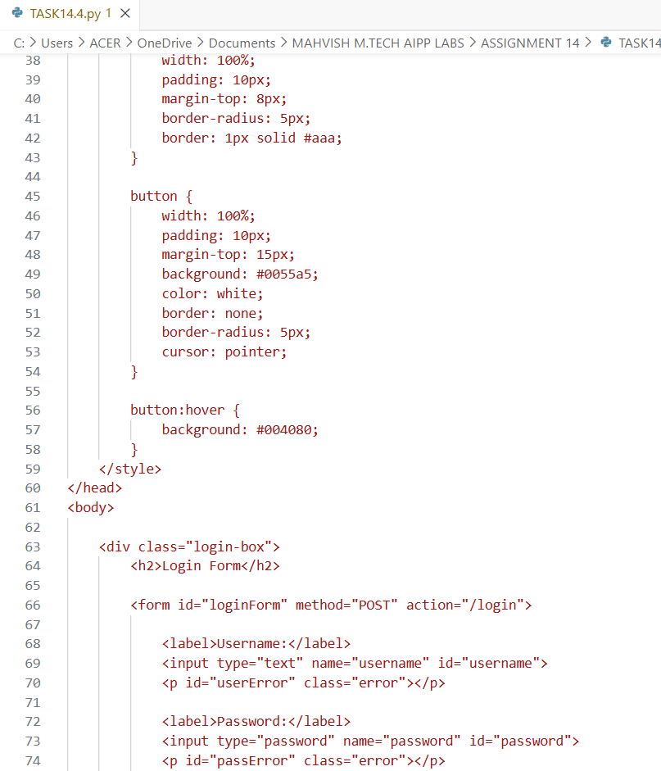
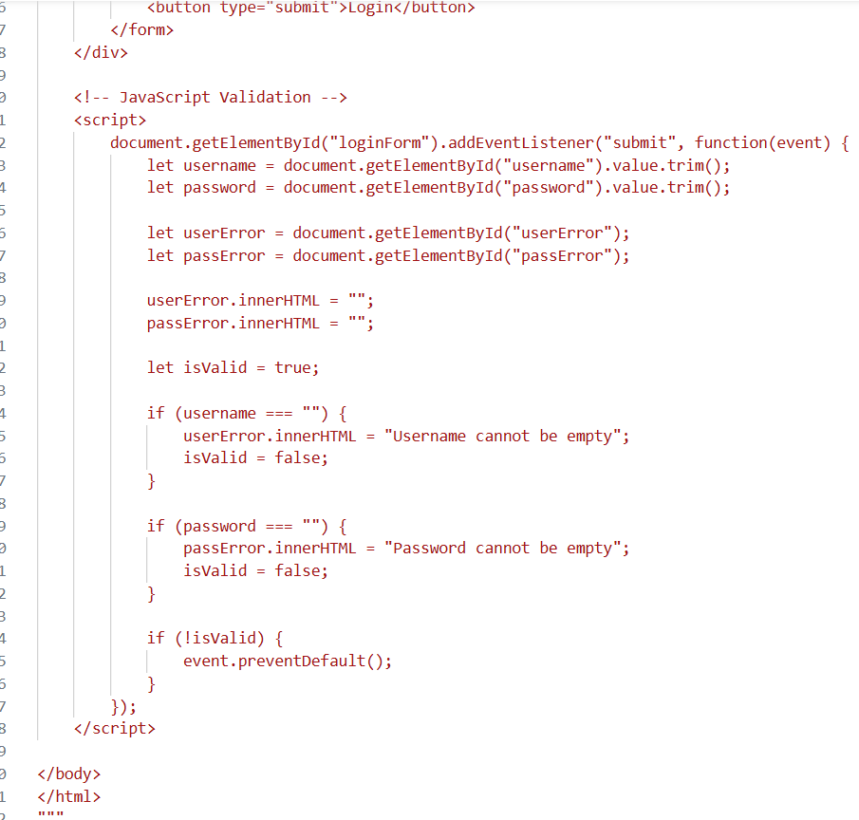
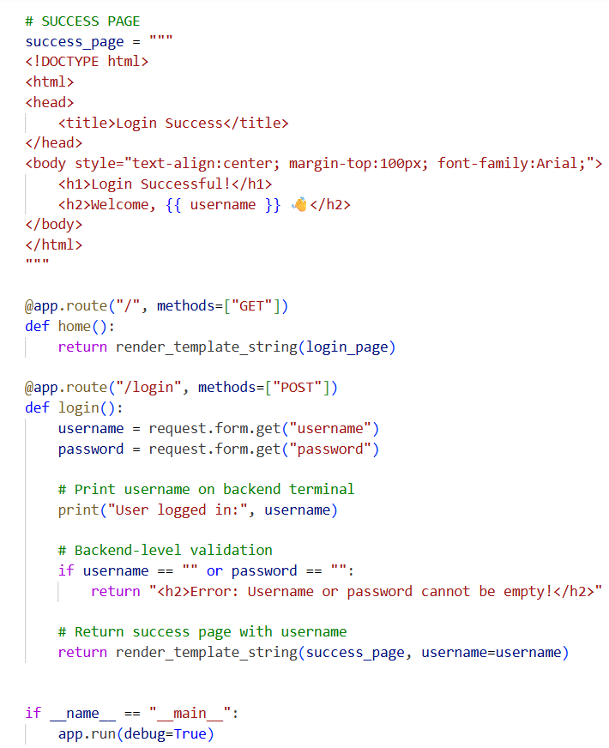

OUTPUT:



